

**Deerwalk Institute of Technology**

**Lab: 5**

**Submitted by: Submitted To:**

Sachin Aryal Narayan Chalise

**Date:** 5th April 2016

1. **Creating a Profile**

* Create a profile and define the maximum login fail attempt in profile.

createProfile.PNG

* Create a user and assign the profile to that user.

createUserAssignProfile.PNG

* After maximum 3 failed attempt, the user account is locked and when user try 4th time locked message is displayed.

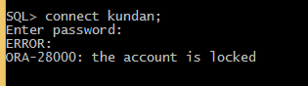



**Deerwalk Institute of Technology**

**Lab: 6**

**Submitted by: Submitted To:**

Sachin Aryal Narayan Chalise

**Date:** 5th April 2016

**Managing Roles**

* Create a user.
* Create a role.
* Assign Role to the user.

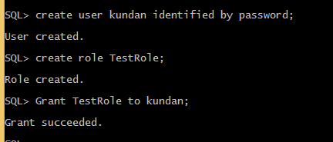

* Granting the privileges to the role

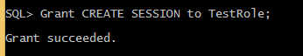

* Granting the privileges to the role with ADMIN OPTION

**grantWithAdminOption.PNG**



**Deerwalk Institute of Technology**

**Lab: 7**

**Submitted by: Submitted To:**

Sachin Aryal Narayan Chalise

**Date:** 5th April 2016

**Managing Privileges**

1. **System Privilege**

* Assign CREATE SESSION Privilege to the user.

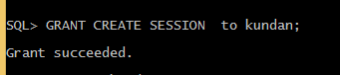

* Trying to grant the CREATE SESSION Privilege to another user by kundan and failed because kundan is not granted with the ADMIN OPTION.

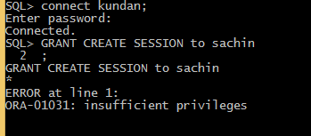

* Create user and role and assign that user to that role.



* Grant CREATE SESSION Privilege to the TestRole, though kundan will also get that Privilege.

**grantWithAdminOption.PNG**

* Trying to grant the CREATE SESSION Privilege to another user by kundan and success because TestRole is granted with the ADMIN OPTION and kundan is assigned to the TestRole.

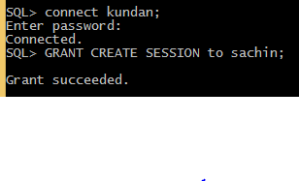

1. **Object Privilege**

* Granting select privilege on the student table of user Prajjwal to the user kundan without GRANT OPTION.

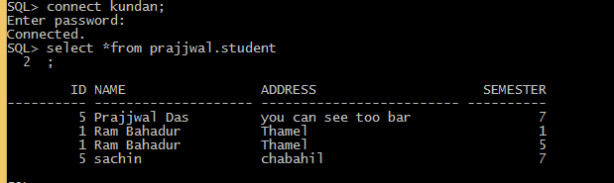

* Trying to use delete query by kundan on user prajjwal’s student table but failed.

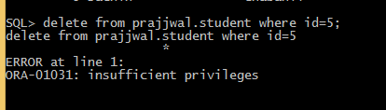

* Trying to GRANT the select privilege on the student table of user Prajjwal to the user sachin by kundan but failed.

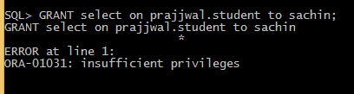

* Granting select privilege on the student table of user Prajjwal to the user kundan with GRANT OPTION.

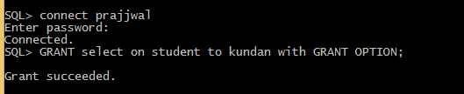

* Trying to GRANT the select privilege on the student table of user Prajjwal to the user sachin by kundan and successes.

